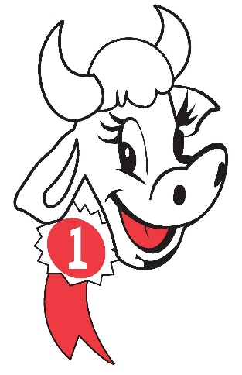 DAIRY FESTIVAL 2024
PARADE PARTICIPATION and LIABILITY RELEASE FORM
The State of Texas:
County of Hopkins:
Know All Men By Presents:
For and in consideration of the permission to participate in the 2024 Hopkins
County Dairy Festival Parade, the undersigned does hereby release the
Hopkins County Dairy Festival, its directors and all individuals associated
which the undersigned or their minor children may suffer as a result of
participation in the 2024 Dairy Festival Parade and agree to hold said
Hopkins County Dairy Festival harmless from any and all liability for
injuries, damages or claims arising from participation in or operating any
equipment associated with said parade.

Signed and dated _______ this day of ______, 2024.

______________________________________________
Participant Name

______________________________________________
Participant Name

_________________________________________________________
Adult Parent/Guardian Signature/Authorized Business Representative

